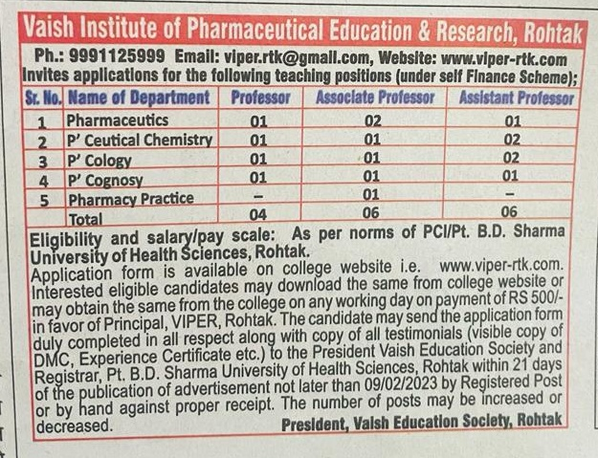

Vaish Institute of Pharmaceutical Education and Research, Rohtak,
(Email Id: viper.rtk@gmail.com, Website: www.viper-rtk.com.)
For office use only: - Sr. No._ _ _ _ _ _ _ _ _ _ Dated_ _ _ _ _ _ _ _ _ _

To

Photo

The President
Vaish Education Society Rohtak

Sub: - Application for the Post of in

Sir,

With reference to your advertisement in dated for the post of in My application may be considered for the said post. My Bio-Data in given below:-
Name Father’s Name Date of Birth Address

Contact
Category GEN SC BC PH ESM (Attach Certificate)

Qualification:-
Examination | Year | Mark Obtained/Max  Marks | %age | Division | Board/University
Matric
Sr. Sec.
B. Pharmacy
M. Pharmacy
Ph. D
NET-JRF/
Gate/GPAT
Others

Experience: (if any)
Sr.  No. | Name of Institution | Post & Nature of  Appointment | From with  Date | To | Total

Total Experience: Years_ Month Days Research Publications etc.:
- No. of Ph.D Scholars Supervised:
- No. of Books Published:
- No. of Papers published in International Journals:

- No. of Papers published in National Journals:

- No. of Paper presented in International Seminars:

- No. of Paper presented in National Seminars:

- NCC/NSS Certificates, if any:

- Cultural Activities/Sports certificate, if any Any other Certificate:
Note: Attach Complete Supporting Documents (self-attested) along with list of Annexure(s).

Note: Apply through proper channel with NOC from the Current Institute/Employer.

Yours Faithfully

Date _ _ _ _ _ _ _ _ _ _ _

Place _ _ _ _ _ _ _ _ _ _

(Signature)

